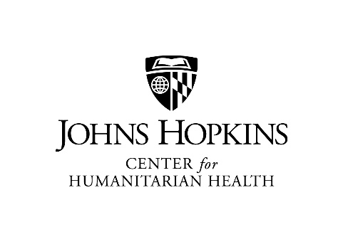
CENTER FOR HUMANITARIAN HEALTH
CERTIFICATE IN HUMANITARIAN HEALTH
DECLARATION OF INTENT

Students who would like to pursue the Certificate in Humanitarian Health should complete this declaration of intent form. The completed form should be submitted to Makieba Duff by email mduff4@jhu.edu.
Questions on the Certificate in Humanitarian Health or its requirements may be directed to Dr. Courtland Robinson, court.robinson@jhu.edu or Dr. Gilbert Burnham, gburnha1@jhu.edu.
Student Name: _____________________________________________________________________ Student ID Number: _________________________________________________________________ Current BSPH Degree Program: ________________________________________________________
Department/Advisor _________________________________________________________________ Mailing Address: ____________________________________________________________________ __________________________________________________________________________________
Phone Number: _____________________________________________________________________ E-mail:_____________________________________________________________________________
Requirements for successful completion:
The certificate program requires a minimum of 18 credits. All required and elective courses must be taken for a letter grade and a minimum overall grade point average (GPA) of 2.75 in all certificate courses is required. The certificate program length is flexible; it varies from student to student; however, the certificate must be completed within three years.
Students should review the Completion of Certificate Program guidelines found on JHSPH’s website before completing the program requirements. Once all requirements are met, students must submit a notification of completion form and copy of unofficial transcript for the certificate.
Student Signature ________________________________________Date _______________________

